I wonder why its given this errors

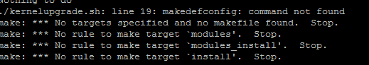

#!/bin/bash

#wget http://cdn.kernel.org/pub/linux/kernel/v4.x/linux-4.12.7.tar.xz

#tar –xvf linux-4.12.7.tar.xz

cd linux-4.12.7

yum groupinstall “Development Tools” -y

yum install openssl* -y

yum install gcc* -y

yum install libncurses5-dev -y

yum install ncurses-devel -y

makedefconfig

make

make modules

make modules_install

make install

echo "your kernel was successfully upgraded"

